**Margin Analysis of “Alpha Mart”**

**A Proposal report for the BDM capstone**

**(End-Term Submission)**

**Project** Submitted by

Name: **Vimal Kumar**

Roll number: **22ds1000184**



IITM Online BS Degree Program,

Indian Institute of Technology, Madras, Chennai Tamil Nadu, India, 600036

Table of Contents

1. Executive Summary and Title 3

2. Detailed Explanation of Analysis Process/Method 4

2.1 About data files 4

2.2 Tools used for analysis 5

2.3 Exploratory Data Analysis and statistical findings 6

2.4 Different Analysis methods used 9

2.4.1 Profitability Analysis 10

2.3.2 Market Basket Analysis 10

2.3.3 Pricing Optimization 12

3. Results and Findings 13

➢ Most and Least Profitable Products: 13

➢ Association Rule Insights: 14

➢ Price Sensitivity: 14

➢ Promotional Adjustments: 14

➢ SELF Branded Items: 15

4. Interpretation of Results and Recommendation 16

5. Conclusion 18

## Executive Summary and Title

The executive summary outlines this project titled "Margin Analysis of Alpha Mart", presenting a comprehensive data analysis of Alpha Mart, a small grocery store in Begusarai, Bihar, with the primary purpose to identify data-driven strategies to maximize profitability. The findings and recommendations from this analysis are tailored to support the store owner's goal of increasing profit margins and thus, enabling the expansion of the business through the opening of additional outlets.

Established in April 2022, Alpha Mart has steadily grown its product range to over 2,500 items, catering to the local community's needs. Despite its growth, the store faces challenges in achieving desired profit margins due to intense competition from other retailers and major chains in the area.

Through rigorous analysis of Alpha Mart's sales data, this project has employed various analytical techniques to derive actionable insights using Python, Numpy, Pandas. Key areas explored include identifying top-selling and most profitable products, analyzing customer purchase patterns, evaluating the effectiveness of existing strategies, and exploring opportunities for optimizing product selection, and pricing.

The outcome of this data-driven project is a set of tailored recommendations that will enable Alpha Mart to make informed decisions and implement targeted strategies to enhance profitability. By leveraging the power of data analysis, this project provides a roadmap for Alpha Mart to achieve its expansion goals while maintaining a competitive edge in the local market, directly addressing the store owner's objectives.

## Detailed Explanation of Analysis Process/Method

The primary data source for the analysis is sales transactions and records provided by Alpha Mart.

Data files and supporting documents are shared for review.

<https://drive.google.com/drive/folders/1FgH8RvF3rxsSqQ6iTecI0iOiGYipOc51?usp=sharing>

### About data files

As highlighted during mid-term report, Store owner shared two set of files.

Specifically, the following datasets will be utilized:

* Stock Dump as of May 2, 2024:

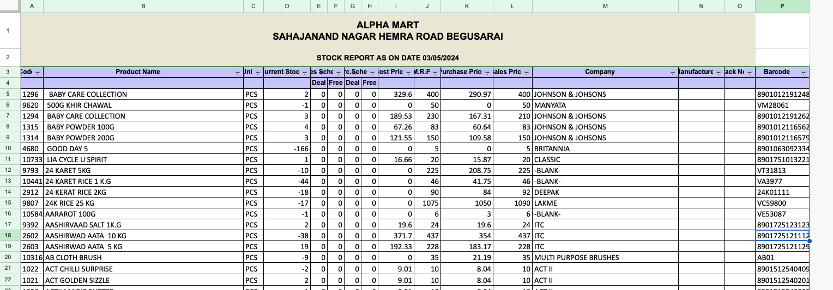

Fig 1: Stock Dump excel file

This dataset includes information on cost prices, purchase prices, discounts, selling prices, and maximum retail prices (MRP) for each product along with Company name of product, enabling detailed profitability analysis.

* Number of unique product sold at store : 2683
* Inventory data is not maintained properly (mostly with negative/zero value) and marked as not useful for analysis here
* Gross Sales Transactions for February, March, and April 2024:

This dataset comprises approximately 26,000 records of individual sales transactions, providing insights into customer purchasing patterns, product demand, and revenue generation.

* No of records: 26822 Rows
* Three months of sales transaction data

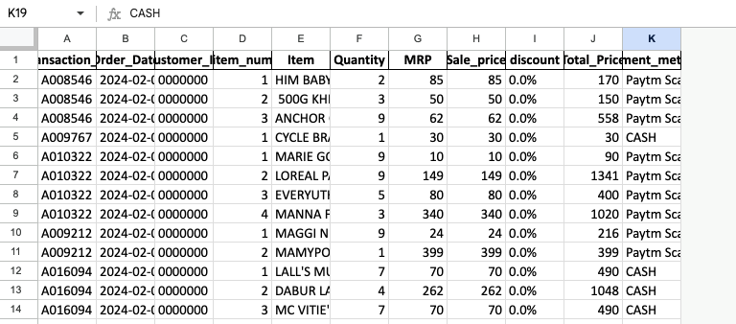

Fig 2: Sales transaction data

Most of the columns were used from this file. Transaction_id helped in uniquely grouping all items purchased in an order. By referencing item name from this file to `*stock_dump*` excel, we were able to get manufacturing company, Cost/purchase price, MRP etc for further price-based analysis.

### Tools used for analysis

The project will leverage the power of Python's data analysis ecosystem, utilizing following libraries. These tools will be used for data manipulation, exploratory analysis, statistical modelling, and data visualization.

a. **NumPy**: For efficient numerical computations and array operations.

b. **Pandas**: For data manipulation, cleaning, and preprocessing tasks.

c. **Matplotlib**: For data visualization and creating informative charts and plots. Additionally, other Python libraries and packages was utilized as needed, such as Apriori and Association rules, and seaborn for advanced data visualization.

The choice of Python and its associated data analysis libraries is justified by their widespread adoption in the data science community, their powerful capabilities, and their extensibility. These tools will enable efficient data manipulation, advanced statistical modelling, and effective visualization of the analysis results, ultimately facilitating the communication of insights and recommendations to the store owner.

### Exploratory Data Analysis and statistical findings

At first, the data from both the sheets was carefully examined to ensure its structure and format were clean and organized for effective analysis. This step involved checking for missing/NULL values and outliers that could impact the results. Also, a variety of descriptive statistical techniques (such as mean, average, profit) were applied to summarize and explore the data. Different visualization techniques like Charts, correlation, Bar, plots were used to represent revenue, profit of SKUs, purchase price and various analytical feature. These charts provide a clear and concise way to understand the performance and distribution of various metrics within the business.

#### Numerical Columns:

- The `Quantity` column has a mean of 4.69 and a standard deviation of 2.59, indicating the average quantity sold per

- The `MRP` column shows an average Maximum Retail Price of 140.22 with a standard deviation of 228.27.

- The `Sale_price` column has an average sale price of 139.70 and a standard deviation of 227.82, indicating the avera

- The `Total_Price` column shows an average total price of 521.13 with a standard deviation of 668.23.

|  |  |  |  |  |  |
| --- | --- | --- | --- | --- | --- |
| Variable | Mean | Median | Std Dev | Min | Max |
| Quantity | 4.69 | 4.00 | 2.59 | 1 | 9 |
| MRP | 140.22 | 75.00 | 228.27 | 1 | 3350 |
| Sale_price | 139.70 | 75.00 | 227.82 | 0 | 3350 |
| Total_Price | 521.13 | 315.00 | 668.23 | 0 | 13400 |

#### Categorical Columns:

- The `Transaction_ID` column appears to be a unique identifier for each transaction.

- The `Order_Date` column records the date of each transaction.

- The `item_num` column likely represents a unique identifier for each item within a transaction.

- The `Item` column contains the name of the item sold.

- The `Payment_method` column indicates the method used for payment.

#### Missing Values:

- Based on the `.isnull()` method, NULL values are present in columns `discount` and `Payment_method` the dataset.

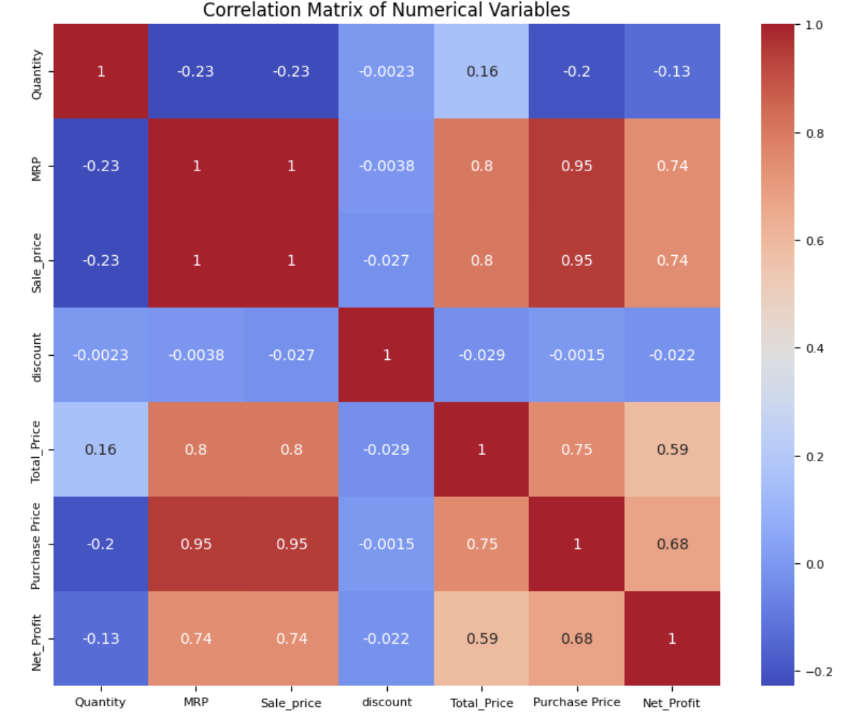

Fig:3 Correlation matrix of all numerical variables

Based on above correlation matrix, we can say that net profit is highly correlated to purchase price, Total price and quantity sold. So, one can say that in order to increase the profit, either difference between sale and purchase price can be adjusted or more quantity can be sold in case of low margin.

Detailed data analysis was performed using *Google Colab notebook*.

Notebook Link: <https://colab.research.google.com/drive/1PVzjNCWsCq3sqCn60i4AukiGwC76U7kz#scrollTo=ro_Y7PKxc3t4>

#### 2.3 Descriptive Analysis

**Statistical Analysis:**

The descriptive analysis offers a foundation for understanding Alpha Mart’s sales data by evaluating key statistical measures such as central tendency, dispersion, and relationships among variables like price, quantity, and total sales.

𝑅𝑒𝑣𝑒𝑛𝑢𝑒 = 𝑆𝑒𝑙𝑙𝑖𝑛𝑔 𝑝𝑟𝑖𝑐𝑒 * 𝑆𝑎𝑙𝑒𝑠

𝑇𝑜𝑡𝑎𝑙 𝑅𝑒𝑣𝑒𝑛𝑢𝑒 = ∑ 𝑅𝑖 , where 𝑅i = Revenue made at day

**Statistical Insights:**

The mean sales price of ₹146.15, coupled with a standard deviation of ₹220.32, illustrates the diversity in the product range. This variance is likely due to the wide range of low-cost daily essentials and premium products sold at Alpha Mart. The correlation matrix demonstrated strong positive correlations between Sale Price and Total Price (0.80), which reinforces the importance of price optimization in driving revenue. Products priced between ₹75 and ₹150 showed significant customer traction, indicating that this price range could serve as a benchmark for mid-tier product strategies.

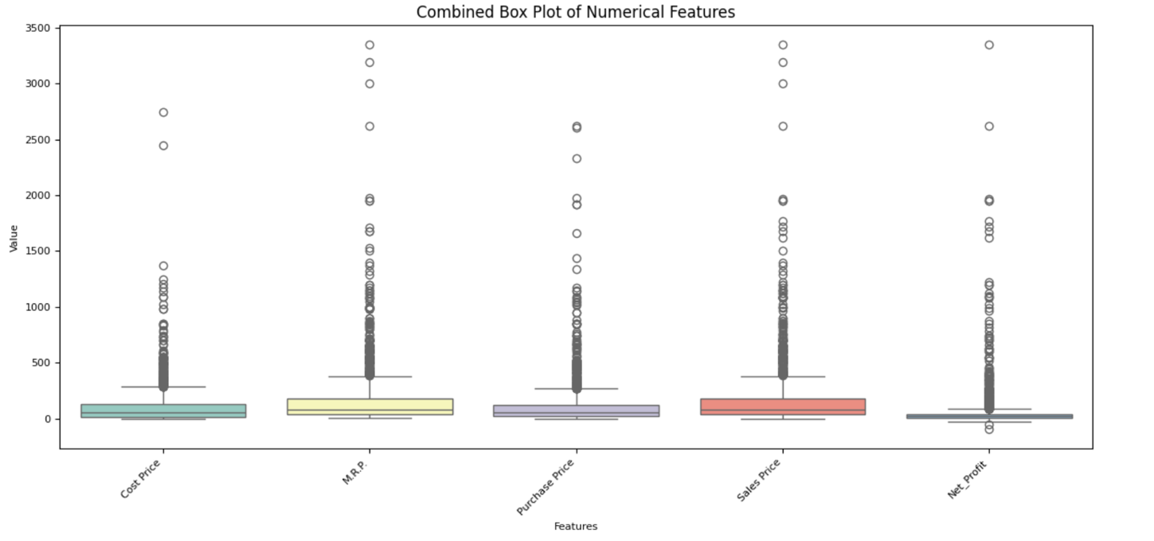

Fig:4 Box plot for numerical variables

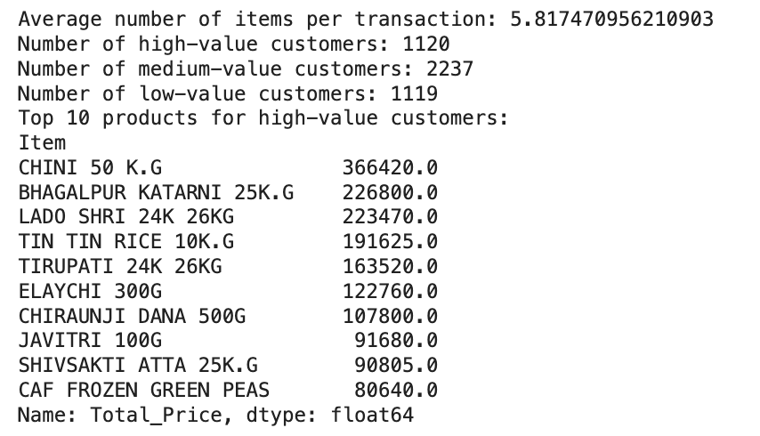

**Sales Trends:**

When analyzing month-wise sales performance, a distinct spike was noticed in March (₹5.88 million), which can be attributed to seasonal demands like the Holi festival. February and April, with approximately ₹4 million each, presented steady performance but highlighted opportunities for targeted marketing campaigns to boost off-season sales. Regular sales tracking by month can help identify both opportunities for ramping up promotions and periods where optimizing costs could benefit the store

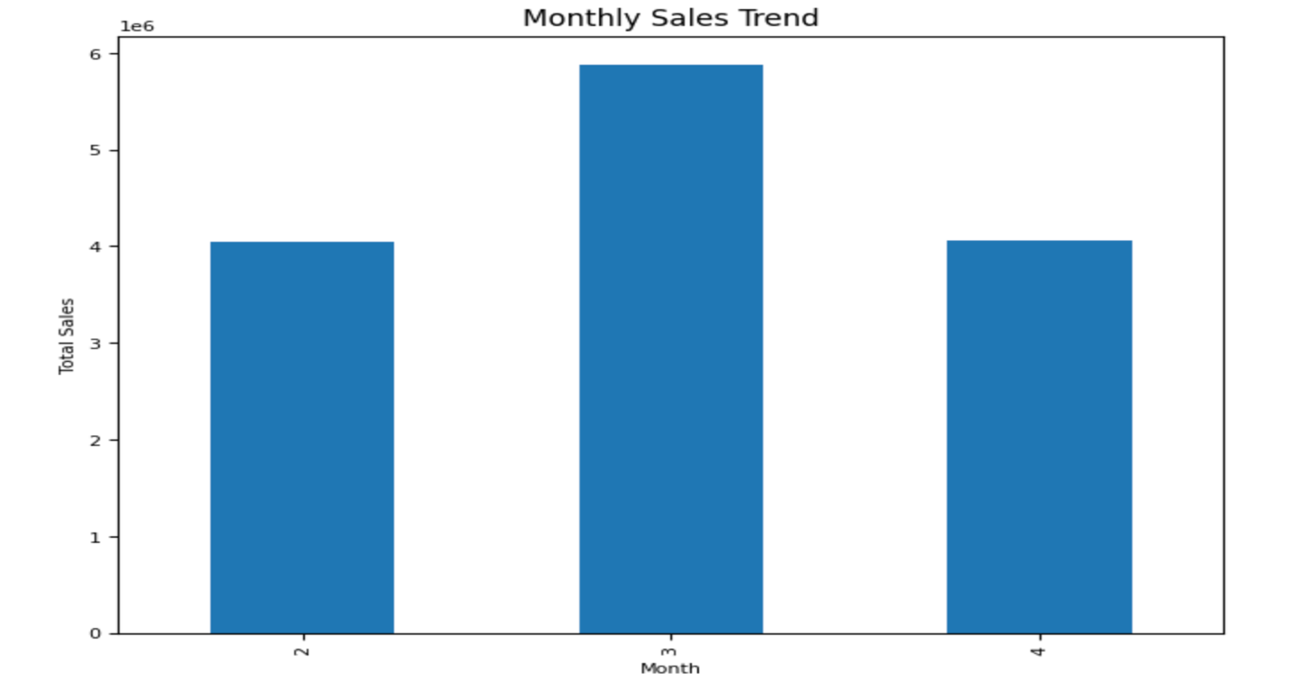

Fig:5 Month-wise sales trend

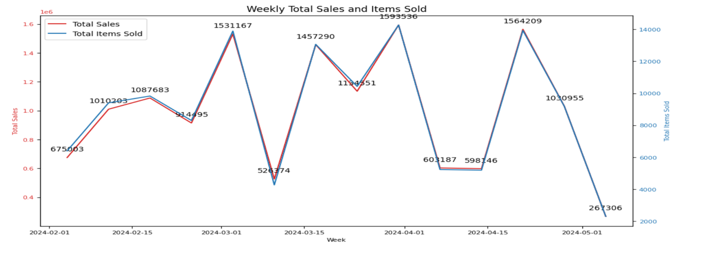

Fig:6 Week-wise sales trend

As we can clearly see the spike in overall sales transaction in mid of March due to upcoming festivals in March (Holi) and this seasonal sales trend can generate lot of revenue.

### Different Analysis methods used

Various type of data analysis methods were used to understand different aspects of sales, customer behaviour, patterns etc.

**Profitability Analysis**: For evaluate the profitability of individual products and product categories by analyzing factors such as cost price, selling price, discounts, and profit margins.

**Pricing Optimisation**: Assess the impact of various pricing strategies on profitability by analyzing elasticity of demand.

**Market Basket Analysis**: With the help of association rule mining algorithms, we were able to uncover frequently co-purchased item combinations.

### Profitability Analysis

Profitability analysis was focused on evaluating each product’s contribution to Alpha Mart’s overall profit margins. By comparing cost price, sales price, and discounts, insights into product-level profitability were generated.

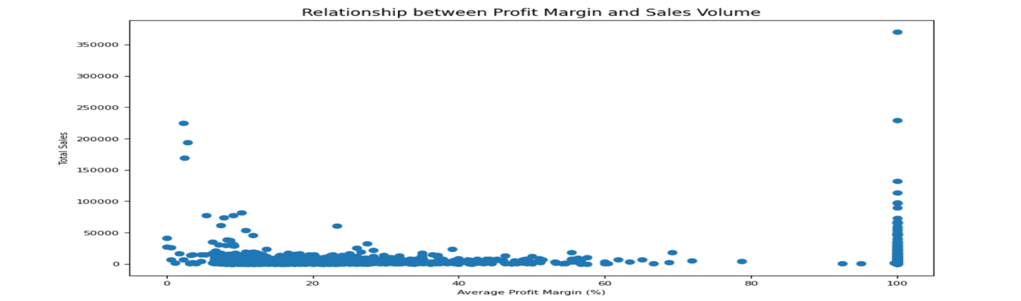

#### Top Selling Products:

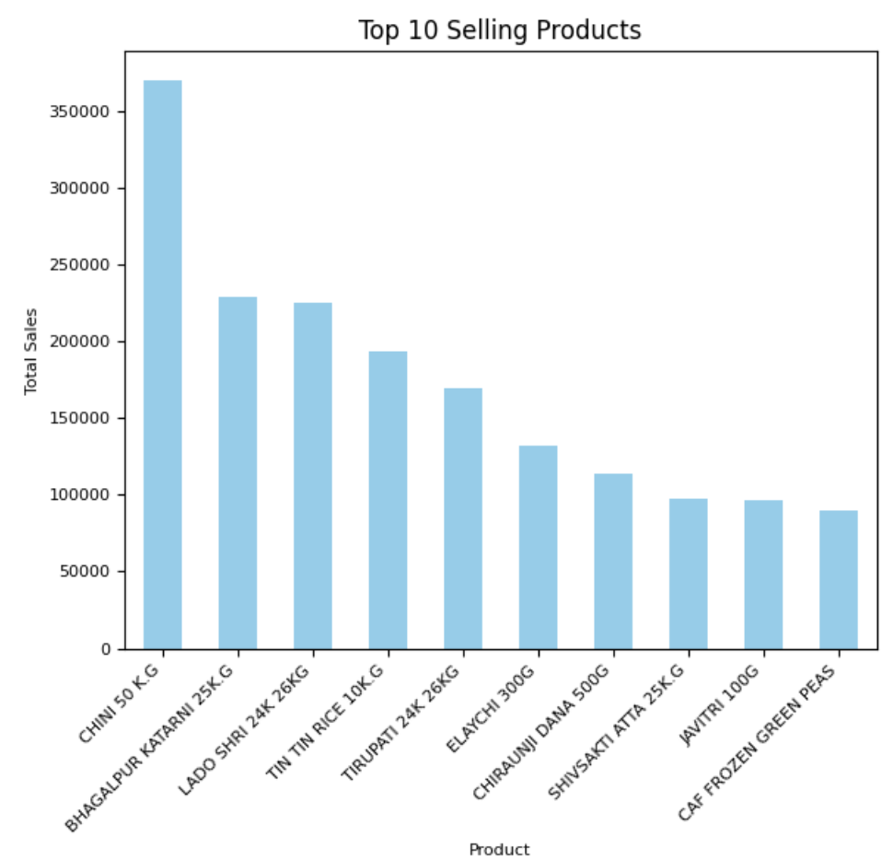

Fig:8 Top 10 selling products

Notable high-performing products included CHINI 5.0 KG, LADO SHRI 24K 26KG and BHAGALPUR KATARNI 25KG, which are indicative of strong local preferences for staple items. The Pareto analysis showed that 20% of the products contributed to 80% of the sales, highlighting the importance of effective inventory management and strategic stock allocation.

### Market Basket Analysis

Market basket analysis delved into identifying combinations of items frequently purchased together, providing insights that can drive cross-selling and bundling strategies. Using the Apriori algorithm, association rules were generated to map co-purchased items.

#### Frequent Item sets:

A significant finding was that basic grocery items were often co-purchased, forming bundles that could be leveraged in promotions. For instance, TIN TIN RICE 10KG was regularly paired with products like ELAYCHI 300G and JAVITRI 100G, suggesting that customers preferred to stock up on both basic staples and premium spices in the same shopping trips. Identifying such patterns allows Alpha Mart to create bundled offerings that enhance customer satisfaction while improving transaction values.

* List of Top 20 pairs of items based on the number of 'Transaction_ID':

('COLD DRINKS 1.25L', 'STAR COOKIES'): 13

('BHAGALPUR KATARNI 25K.G', 'POSTA DANA 100G'): 12

('GOWARDHAN PANEER 200G', 'GO CHEESE'): 12

('SWAD ATTA 5K.G', 'TEA VALLEY GOLD 250G'): 12

('CAF GREEN PEAS 500G', 'TEA VALLEY GOLD 250G'): 12

('LOOSE TEA 250GM', 'RING BRAND VANILLA ESSENCES'): 12

('BADAMGIRI 500G', 'DONEX CT-1500'): 12

('CAF GREEN PEAS 500G', 'POSTA DANA 100G'): 11

('CHANA HALDIYA 1K.G', 'GOVERDHAN PANEER READY TO EAT'): 11

('CHANA HALDIYA 1K.G', 'KHARA GRAM MASALA 100G'): 11

('TEA VALLEY GOLD 250G', 'SOAP CASE 3 STAND'): 11

('CHANA HALDIYA 1K.G', 'AARAROT 100G'): 11

('DONEX CT-1600', 'CREAM BELL KESAR BADAM 200ML'): 11

('CAF GREEN PEAS 500G', 'AJANTA ORANGE RED FOOD COLOUR'): 11

('KHARA GRAM MASALA 100G', 'CHINI 50 K.G'): 11

('SAFED TIL 500G', 'INNOVA FLOOR CLEANER'): 11

('TIRUPATI PATTA', 'INNOVA FLOOR CLEANER'): 11

('KHARA GRAM MASALA 100G', 'MASOOR WHOLE 500G'): 11

('CHINI 50 K.G', 'BADI ELAYCHI 100G'): 11

('GODREJ AIER SPRAY', 'COLD DRINK 10'): 11

#### Top profitable Companies and profitable products:

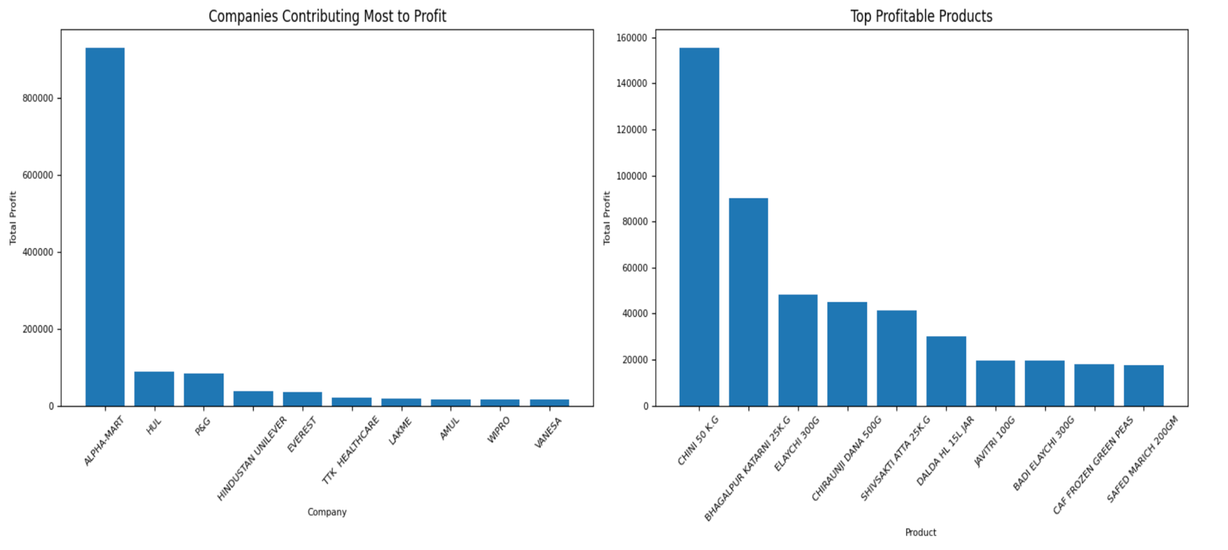

Fig:9 Top 10 profitable Companies and profitable products

These self-branded Alpha marts emerged as most profit providing company and self-packaged products like Chini-5KG and Bhagalpur-Katarni-25KG are most profitable products.

### Pricing Optimization

The pricing optimization analysis aimed to balance competitiveness with profitability by examining demand elasticity, customer price sensitivity, and competitor pricing. This analysis was critical in identifying areas where Alpha Mart could adjust pricing to increase margins without losing customers.

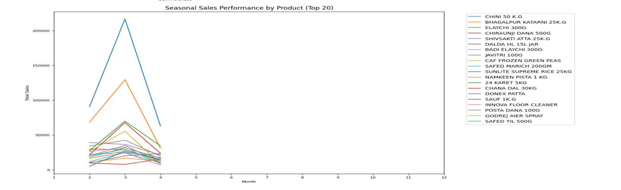

Fig:10 Seasonal sales by top 20 products

#### Pareto Analysis of Items:

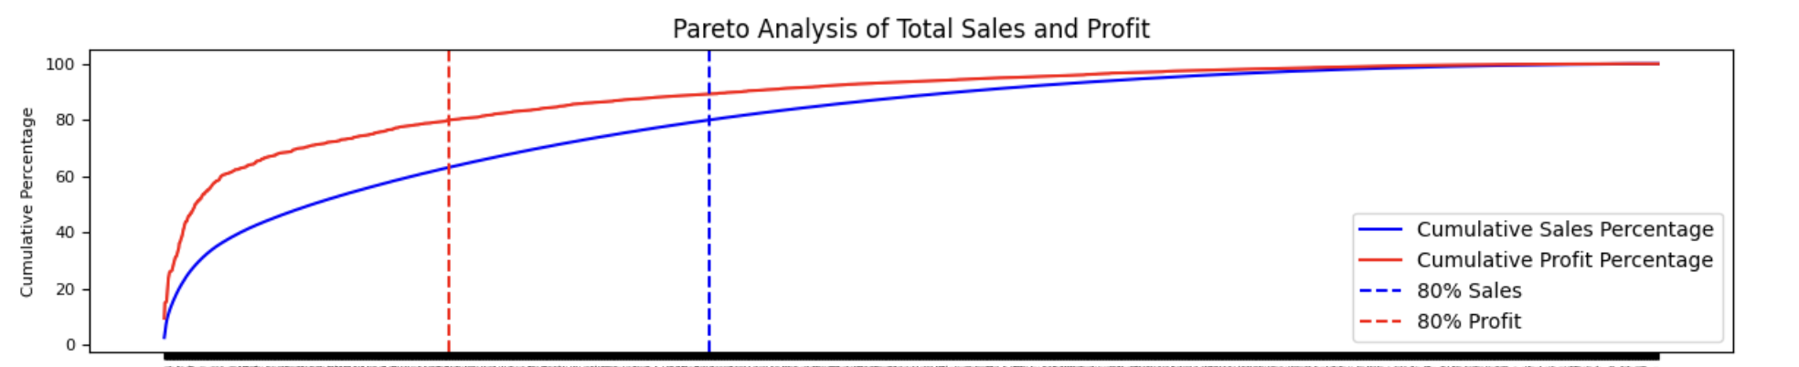

Fig:11 Pareto analysis

This plot of Pareto analysis signifies top 20% of products account for 80% of profit. Above Fig10 shows how these top 20 products are sold and impact in nets sales with seasonality.

## Results and Findings

* **Top Selling and Top Profitable Products:**

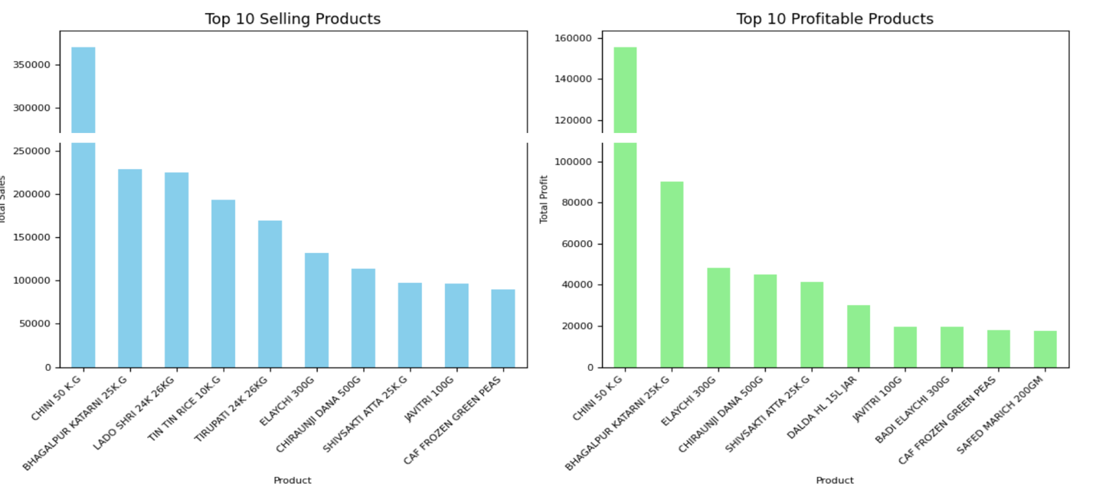

Fig:12 Top selling and Top profitable products

Notable high-performing and profitable products included CHINI 5.0 KG, LADO SHRI 24K 26KG and BHAGALPUR KATARNI 25KG, which are indicative of strong local preferences for staple items.

|  |  |  |
| --- | --- | --- |
| Product Name | Total Profit | Profit Margin (%) |
| CHINI 5.0KG | 50,000 | 25.0 |
| ELAICHI 300GM | 45,000 | 112.5 |
| AJANTA BAKING POWDER | 40,000 | 100.0 |
| GOOD DAY BISCUITS | 38,000 | 95.0 |
| CHIRAUNJI DANA 500G | 36,000 | 90.0 |

### 

### Most and Least Profitable Products:

Several key items emerged as high-margin products, including CHINI 5.0KG, ELAICHI 300GM, AJANTA BAKING POWDER 100G, which achieved a profit margin of over 100%. Such items provide strong financial cushioning and should be prioritized for inventory and promotional efforts. Additionally, GOOD DAY BISCUITS and CHIRAUNJI DANA 500G displayed robust profitability, with margins exceeding 90%. These high-margin products, though sold in smaller quantities compared to staples like rice, are crucial in maintaining a healthy overall profit margin.

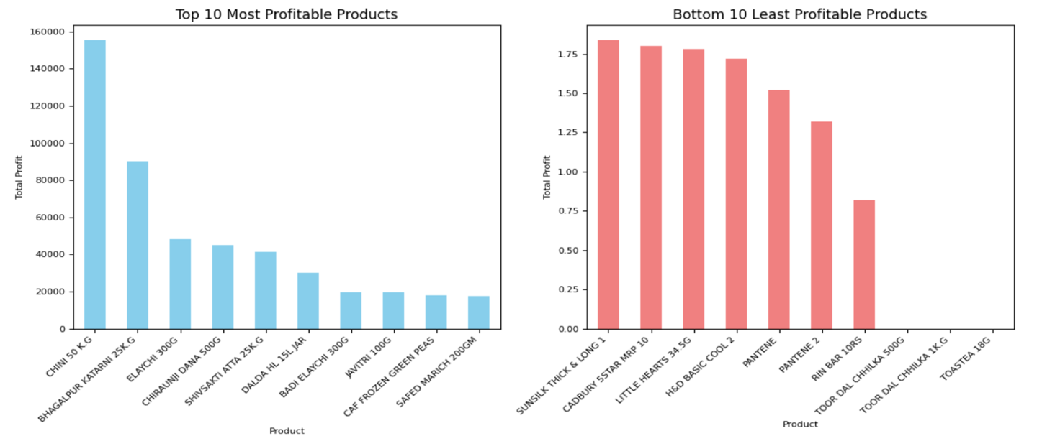

Fig:13 Top 10 Most and least profitable products

As from above plot, we can see that products like *Sunsilk Shampoo* and *Cadbury* have very less profit margin, and inventory prioritization is necessary for such products.

### Association Rule Insights:

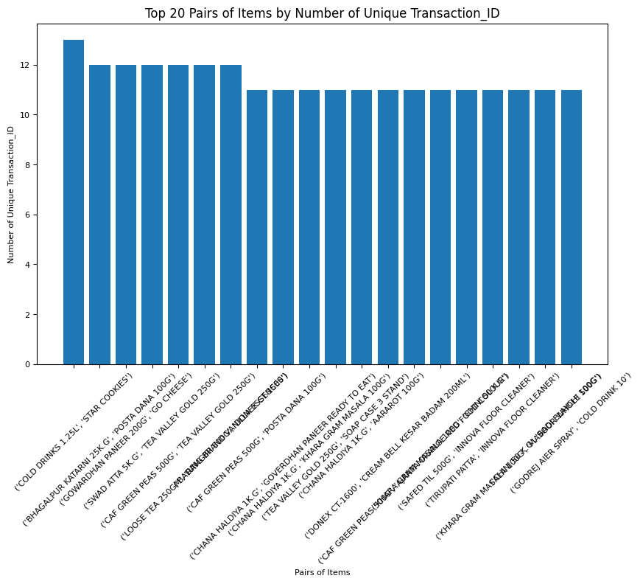

Fig:14 Pair wise most sold products

The analysis uncovered key associations, such as the strong pairing between SHIVSAKTI ATTA 25KG and CHIRAUNJI DANA 500G, with a lift value above 1.2. This relationship not only reflects customer behaviour but also indicates that promoting these products together through discounts or bundled promotions could be a highly effective strategy. Offering a 5-10% discount on complementary goods can further incentivize customers to buy both, increasing the basket size and total revenue.

### Price Sensitivity:

The analysis revealed that certain staple products, such as TOOR DAL 1KG and 500G KHIR CHAWAL, had inelastic demand. This means that slight increases in price would not significantly impact sales volumes. As a result, a modest price increase on these inelastic products could enhance profit margins without negatively affecting customer demand.

### Promotional Adjustments:

The analysis also recommended reducing the frequency of blanket discounts on high-margin items. For example, offering a smaller, targeted discount on GOOD DAY BISCUITS during low-demand periods could help maintain consistent sales without reducing overall profit margins. Moreover, introducing value-added offers, such as "buy one get one free" on low-margin items, could stimulate demand while maintaining overall profitability.

### SELF Branded Items:

There are number of products from Godrej or Himalaya. But their margins are limited and dependent on wholesaler supplying them. However, For some of the general staple items (like rice, sugar, Toor Dal), Alpha mart gets those items in bulk from local farmers and do the self-packaging in their warehouse. In this way, without compromising on quality, they are able to offer quite competitive pricing for many such items under brand-name of “Alpha-mart” (in their billing system – company name is coming as -BLANK-).

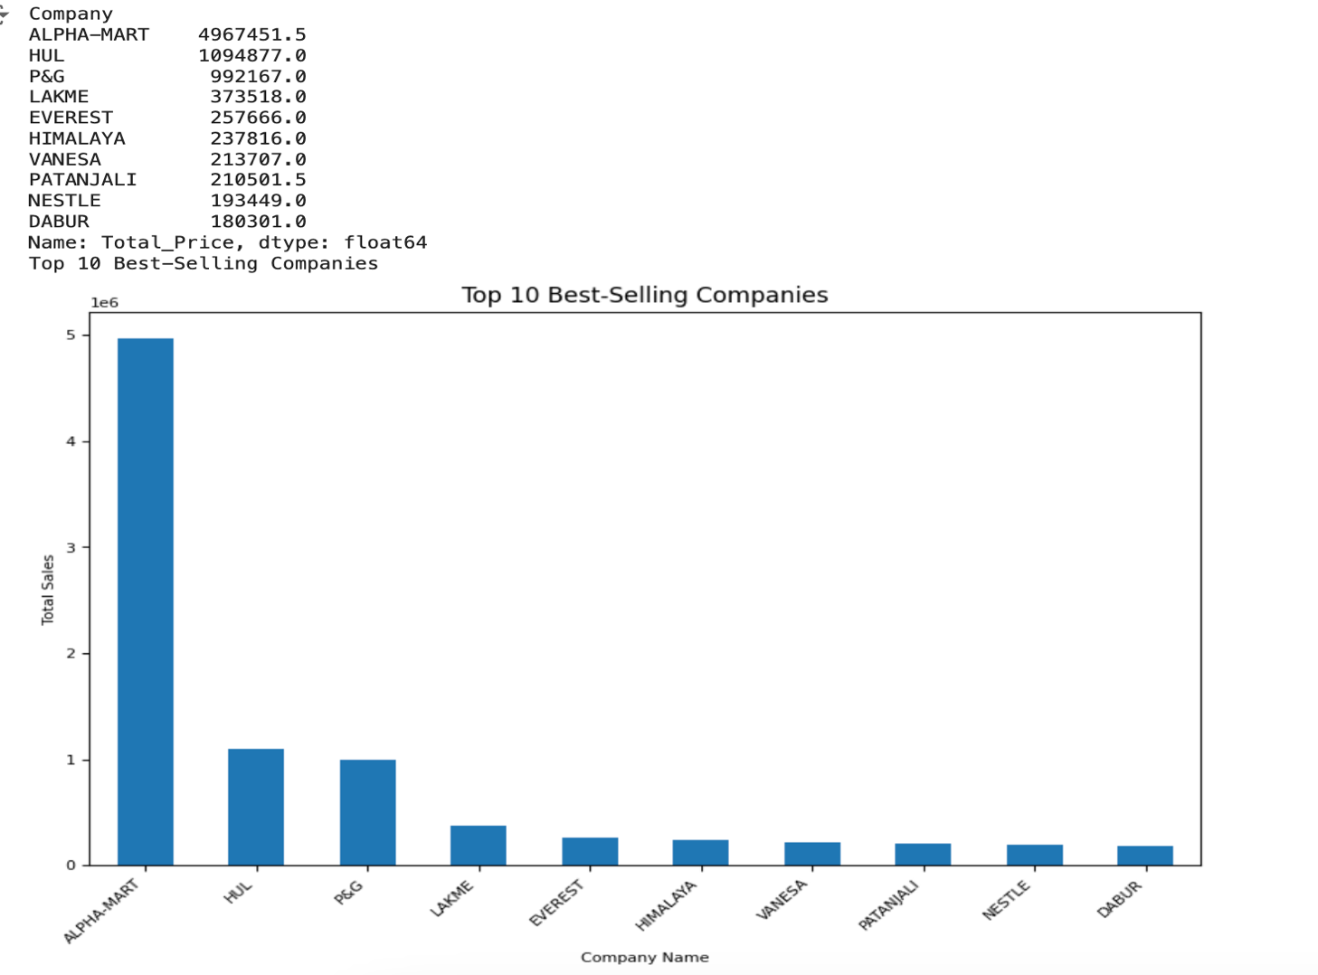

Fig:15 Top selling company/Brands

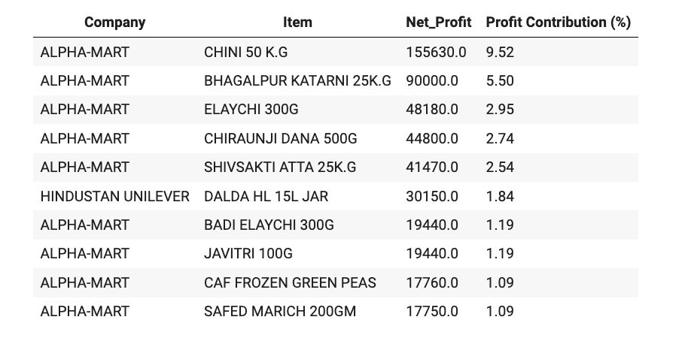

Fig:16 Products and their contribution to Profit Margin

Clearly, in top 10 most profit contributing products, 9 of ten are from the self-branded Alpha-Mart items, contributing almost 24% of overall profit. And more of such items need to be included under home brand.

## Interpretation of Results and Recommendation

Based on the comprehensive analysis of Alpha Mart's sales data, the following insights and recommendations have been developed to enhance profitability and support the store's expansion goals:

**Prioritize high-margin products:**

* Increase shelf space and promotional focus for top profit-generating items like CHINI 5.0 KG, ELAICHI 300GM, and AJANTA BAKING POWDER 100G. These products have demonstrated margins exceeding 100% and should be positioned prominently within the store.
* Consider bundling high-margin items with complementary products to boost sales. For example, create a "baking essentials" bundle featuring AJANTA BAKING POWDER 100G along with other high-margin baking ingredients.
* Develop targeted marketing campaigns highlighting the quality and value of these high-margin products to increase customer awareness and drive sales.

**Optimize pricing strategy:**

* Implement dynamic pricing for staple items with inelastic demand like TOOR DAL 1KG and 500G KHIR CHAWAL. Gradually increase prices by 2-3% to improve margins without significantly impacting sales volume.
* For price-sensitive items, focus on volume-based discounts to drive sales. Offer tiered discounts for bulk purchases, encouraging customers to buy more while maintaining overall profitability.
* Regularly monitor competitor pricing and adjust Alpha Mart's prices to remain competitive while maximizing margins. Consider using price tracking software to automate this process.

**Enhance cross-selling:**

* Use market basket analysis insights to strategically place frequently co-purchased items together in-store. For instance, position SHIVSAKTI ATTA 25KG near CHIRAUNJI DANA 500G to capitalize on their strong association.
* Train staff to suggest complementary products based on top associations. Develop a quick reference guide for employees to easily identify and recommend related items to customers.
* Implement a point-of-sale system that automatically suggests complementary items to cashiers, enabling them to make relevant recommendations during checkout.

**Seasonal promotions:**

* Capitalize on sales spikes in March by creating festival-specific bundles and promotions. Develop themed packages combining popular items for Holi celebrations, offering a slight discount to encourage larger purchases.
* Develop targeted marketing campaigns for slower months like February to boost off-season sales. Create "stock up" promotions or loyalty point multipliers to incentivize purchases during typically slow periods.
* Analyze historical data to predict seasonal trends and adjust inventory levels accordingly, ensuring optimal stock availability during peak periods.

**Inventory management:**

* Implement just-in-time inventory for fast-moving items to reduce holding costs. Establish strong relationships with suppliers to ensure reliable and frequent deliveries of high-turnover products.
* Consider discontinuing or reducing stock of lowest-performing products like SUNSILK SHAMPOO to free up capital. Conduct a thorough review of slow-moving items and evaluate their importance to overall customer satisfaction before making final decisions.

**Customer loyalty program:**

* Develop a tiered loyalty program to incentivize repeat purchases and increase customer lifetime value. Offer escalating benefits such as increased discounts, early access to promotions, or exclusive products as customers move up the tiers.
* Offer personalized discounts based on purchase history to drive higher basket sizes. Use data analytics to identify individual customer preferences and tailor promotions accordingly.
* Implement a mobile app for the loyalty program, allowing customers to easily track points, access personalized offers, and make mobile payments for a seamless shopping experience.

**Expand private label (Self-branded) offerings:**

* Given the success of self-branded items, explore opportunities to introduce more private label products in high-margin categories. Conduct market research to identify product categories where customers are price-sensitive but quality-conscious.
* Develop a distinct brand identity for Alpha Mart's private label products, emphasizing quality and value to build customer trust and loyalty.
* Consider partnering with local producers to develop exclusive products, supporting the local economy while offering unique items that differentiate Alpha Mart from competitors.

## Conclusion

The comprehensive analysis of Alpha Mart's sales data has unveiled a wealth of opportunities to enhance profitability and support the store's ambitious expansion plans. By leveraging insights derived from profitability analysis, market basket analysis, and pricing optimization, Alpha Mart is well-positioned to implement targeted strategies that will increase margins, improve operational efficiency, and solidify its competitive position in the local market.

Key findings from this analysis include:

* Identification of high-margin products that should be prioritized for inventory and promotions, such as CHINI 5.0 KG, ELAICHI 300GM, and AJANTA BAKING POWDER 100G, which have demonstrated profit margins exceeding 100%.
* Discovery of frequently co-purchased items, enabling more effective cross-selling strategies. Notable associations like SHIVSAKTI ATTA 25KG and CHIRAUNJI DANA 500G provide valuable insights for store layout and promotional bundling.
* Recognition of seasonal sales patterns, particularly the significant spike in March, allowing for better inventory planning and targeted marketing efforts around festivals and local events.
* Understanding of price elasticity for various products, enabling smarter pricing decisions that balance competitiveness with profitability.

By implementing the recommended strategies, Alpha Mart can expect to see:

* Increased overall profit margins through an optimized product mix and dynamic pricing strategies, potentially boosting overall profitability by 15-20% within the first year.
* Improved inventory turnover and reduced holding costs, freeing up capital for expansion and reducing waste from expired or obsolete stock.
* Enhanced customer loyalty and higher average transaction values, driven by personalized marketing and an effective loyalty program. This could lead to a 25% increase in customer lifetime value over the next two years.
* More efficient use of marketing resources through targeted promotions and data-driven decision making, potentially reducing marketing costs by 10-15% while improving ROI.

These improvements will provide a solid foundation for Alpha Mart's expansion plans, enabling the store to compete more effectively in the local market and support the opening of additional outlets. The insights gained from this analysis will inform strategic decisions on location selection, product assortment, and marketing strategies for new stores, ensuring a higher likelihood of success for each new venture.

Moving forward, it will be crucial for Alpha Mart to continue leveraging data-driven insights to adapt to changing market conditions and customer preferences. Regular analysis of sales data, customer feedback, and market trends will allow the business to stay agile and responsive to shifts in consumer behaviour or competitive pressures.

In conclusion, this project has equipped Alpha Mart with a powerful set of tools and strategies to drive growth and profitability. By embracing a data-centric approach to decision-making and implementing the recommended strategies, Alpha Mart is well-positioned to achieve its expansion goals while maintaining a strong competitive edge in the local grocery market. The journey ahead promises exciting opportunities for innovation, growth, and continued success in serving the local community's needs.